INTRODUCTION

The rapid advancement of internet technologies and the widespread adoption of e-commerce platforms have significantly transformed the way consumers purchase products. Online shopping platforms such as Amazon and Flipkart provide customers with the ability to browse products, compare prices, and read customer reviews before making purchasing decisions. Among these features, customer reviews play a crucial role in influencing buyer behavior.
Customer reviews contain valuable opinions and feedback regarding product quality, performance, pricing, and overall satisfaction. However, due to the increasing number of reviews posted daily, it becomes difficult for users to manually analyze all feedback and make informed decisions. Furthermore, comparing customer sentiment across multiple platforms adds another layer of complexity.
Sentiment Analysis, a branch of Natural Language Processing (NLP), provides a solution to this problem by automatically classifying textual reviews into predefined sentiment categories such as Positive, Negative, and Neutral. By applying sentiment analysis techniques to customer reviews, meaningful insights can be generated efficiently.
The Product Sentiment Analysis Dashboard is designed to integrate review analysis and price comparison within a single web-based platform. The system enables users to select products, compare prices across platforms, and analyze customer sentiment using graphical representations and summary insights.
This project demonstrates how data analytics, NLP techniques, and web technologies can be combined to build a practical and intelligent decision- support system.

OVERVIEW OF THE PROJECT

The Product Sentiment Analysis Dashboard is a web-based analytical system developed to evaluate customer reviews and compare product pricing across e-commerce platforms. The primary objective of the system is to assist users in understanding customer perception and price variations before making a purchase decision.
The system processes review data stored in a structured dataset (reviews.csv), which contains product information, platform details, and customer review text. Using sentiment analysis techniques, each review is classified into one of three categories:
    - Positive
    - Negative
    - Neutral

The system calculates the percentage distribution of sentiments for selected products and displays the results in graphical format using charts. Additionally, it compares product prices across platforms such as Amazon and Flipkart and identifies the cheaper option.
The dashboard provides a user-friendly interface where:

- Users can select a product.
- View price comparison results.
- Analyze platform-wise sentiment distribution.
- Access business insight summaries generated based on sentiment results.

The system is implemented using Python, Flask, Pandas, TextBlob, and Matplotlib, ensuring efficient backend processing and effective data visualization.

1. MODULES DESCRIPTION

The Product Sentiment Analysis Dashboard is divided into several functional modules to ensure organized system development and smooth execution.

Welcome Module

This module serves as the entry point of the application. It provides basic information about the system and allows users to navigate to the product comparison dashboard.

Product Selection Module

This module allows users to select a specific product from the available product list. The selection dynamically filters relevant data from the dataset.

Price Comparison Module

This module compares product prices across different platforms. It displays platform-wise pricing details and highlights the cheaper option for the selected product.

Sentiment Analysis Module

This module performs sentiment classification using Natural Language Processing techniques. It analyzes review text and categorizes them into Positive, Negative, or Neutral sentiments.

Visualization Module

This module generates graphical representations of sentiment distribution using charts. It improves user understanding by presenting data in a visual format.

Business Insight Generation Module

This module generates summary insights based on sentiment results. It provides meaningful interpretations such as overall customer satisfaction level and potential improvement areas.
Each module works collaboratively to provide an integrated and interactive analytical dashboard.

SYSTEM STUDY

System study involves analyzing the current methods used for product review evaluation and price comparison, identifying their limitations, and proposing an improved solution. This phase helps in understanding the practical challenges faced by users and justifies the need for the proposed system.

EXISTING SYSTEM

In the present scenario, customers depend heavily on e-commerce platforms such as Amazon and Flipkart to gather information about products before purchasing them. These platforms provide product descriptions, ratings, and customer reviews to help users evaluate product quality and performance.
The existing system allows users to manually read individual reviews to understand customer opinions. Each review contains textual feedback expressing satisfaction, dissatisfaction, or neutral experience regarding the product. However, these reviews are displayed in raw textual format without structured sentiment classification.
For price comparison, users are required to visit different platforms separately and check the price of the same product manually. This process involves searching for the product multiple times and comparing prices across different websites.
Although these platforms provide rating systems (such as star ratings), they do not offer detailed sentiment categorization of textual reviews. Ratings alone may not reflect the complete customer opinion, as textual reviews often contain mixed sentiments.

Therefore, the existing system primarily depends on manual analysis, which may lead to inefficient decision-making and incomplete understanding of customer perception.

DRAWBACKS

The existing system has several limitations:

Manual Analysis of Reviews
Customers must read numerous reviews individually, which consumes time and effort.

Unstructured Review Data
Reviews are presented as raw text without classification into sentiment categories.

No Integrated Price and Sentiment Comparison
Price comparison and review analysis are not combined within a single analytical interface.

Lack Of Data Visualization
There is no graphical representation such as charts or percentage distribution to summarize customer feedback.

Inconsistent Decision Support
Due to mixed reviews and absence of structured analysis, customers may find it difficult to make confident purchasing decisions.

PROPOSED SYSTEM
The proposed system, titled Product Sentiment Analysis Dashboard, is a web-based analytical application designed to automate the process of review analysis and product price comparison across multiple e-commerce platforms.
Unlike the existing system, the proposed system integrates sentiment analysis, price comparison, and data visualization within a single unified dashboard. The system processes review data from a structured dataset and applies Natural Language Processing (NLP) techniques to classify customer feedback into meaningful sentiment categories.
The application allows users to select a product and automatically generates:
- Platform-wise price comparison
- Sentiment classification results
- Percentage distribution of sentiments
- Graphical representation of analysis
- Insight-based summary conclusions

By combining review mining and price comparison, the proposed system simplifies decision-making and reduces the effort required for manual analysis.
The system is implemented using Python and Flask as the backend framework. It utilizes data processing libraries for efficient handling of review data and visualization libraries for graphical output generation.
This approach ensures structured analysis, improved clarity, and better user experience.

FEATURES
The proposed system provides the following key features:

1.Automated Sentiment Classification
The system automatically classifies product reviews into Positive, Negative, and Neutral sentiments using Natural Language Processing techniques.

2.Platform-Wise Comparison
It compares the same product across multiple platforms such as Amazon and Flipkart.

3.Price Comparison Module
The system identifies and displays the cheaper platform for the selected product.

4.Graphical Visualization
Sentiment distribution is presented using charts for better understanding and interpretation.

5.User-Friendly Interface
The web-based dashboard provides a simple and interactive interface for product selection and result viewing.

6.Insight Generation
The system generates meaningful conclusionsbased on sentiment percentage distribution to assist in decision-making.

7.Structured Data Processing
Review data is handled using a structured dataset to ensure accurate and consistent analysis.

ADVANTAGES

The proposed system offers several advantages over the existing system:

Time Efficiency
Automated sentiment analysis reduces the need for manual review reading.

Integrated Analysis

Combines price comparison and sentiment evaluation in one dashboard.

Visual Representation
Graphical charts improve clarity and interpretation of data.

Scalability
The system can be expanded to include more products and platforms in the future.

SYSTEM SPECIFICATION
System specification defines the technical requirements and operational environment necessary for developing and executing the Product Sentiment Analysis Dashboard. It ensures that the system runs efficiently and provides consistent performance during data processing and visualization tasks.

HARDWARE SPECIFICATION
The Product Sentiment Analysis Dashboard is designed as a lightweight web-based application and does not require high-end hardware infrastructure. It can be developed and executed on standard personal computing systems available in academic laboratories or home environments.
The minimum hardware requirements are as follows:
- Processor: Intel Core i3 / AMD equivalent or higher
- RAM: 4 GB (8 GB recommended for better performance)
- Storage: 500 GB Hard Disk or SSD
- System Architecture: 64-bit system
- Input Devices: Keyboard and Mouse
- Output Device: Monitor
- Network Requirement: Internet connection (for development references and updates)
Although the system runs locally using Flask’s development server, it can also be deployed on cloud platforms if required in the future. The hardware configuration ensures smooth execution of data processing, sentiment computation, and graphical visualization.

SOFTWARE SPECIFICATION
The system is developed using modern programming tools and libraries that support web development, data processing, and Natural Language Processing.
The required software components are:

- Operating System: Windows 10 / Windows 11
- Programming Language: Python 3.x
- Backend Framework: Flask
- Frontend Technologies: HTML5, CSS3
- Data Handling Library: Pandas
- Sentiment Analysis Library: TextBlob
- Visualization Library: Matplotlib
- Development Environment: Visual Studio Code / PyCharm
- Browser Support: Google Chrome, Microsoft Edge

Python is selected due to its simplicity, readability, and extensive library support for data analysis and NLP tasks.
Flask is used as a lightweight web framework that manages routing, server communication, and backend logic.
Pandas is utilized for efficient handling of structured datasets such as CSV files.
TextBlob performs polarity-based sentiment computation, enabling automatic classification of review text.
Matplotlib generates graphical charts to visually represent sentiment distribution.

SOFTWARE FEATURES
The Product Sentiment Analysis Dashboard includes the following enhanced software features:

Interactive Web Interface
Provides a clean and user-friendly interface for selecting products and viewing analysis results.

Structured Dataset Processing
Reads and processes review data from a CSV file containing product details, platform name, price, and review text.

Automated Sentiment Categorization
Applies polarity-based analysis to classify reviews as Positive, Negative, or Neutral.

Platform-Based Filtering
Separates review sets for Amazon and Flipkart for comparative analysis.

Price Identification Mechanism
Identifies and displays the lower-priced platform for the selected product.

Graphical Representation of Results
Generates bar charts or similar visual representations to display sentiment percentage distribution.

Modular Architecture
Backend logic is separated into functions for maintainability and clarity.

Error Handling Mechanism
Includes basic validation to prevent runtime errors during product selection.

Scalable Design
New products and additional platforms can be integrated easily by updating the dataset.

Local Deployment Capability
The application runs using a local Flask server and can be deployed to hosting services if required.

SYSTEM DESIGN
System design is an important phase in software development where the overall structure of the system is planned before implementation. It defines how the system will operate, how users will interact with it, and how data will be processed to generate meaningful results.
The Product Sentiment Analysis Dashboard is designed as a web-based application that integrates price comparison and sentiment analysis into a single interactive platform. The design focuses on simplicity, usability, efficiency, and clarity of output.
The system follows a structured and modular design approach. Each component of the system performs a specific function, ensuring that the application works smoothly without unnecessary complexity.
The main objective of the system design is:

- To provide an easy interface for product selection
- To ensure accurate price comparison between platforms
- To generate clear sentiment classification results
- To visually represent analysis using graphical methods
- To provide meaningful business insights

The design ensures that even users with basic technical knowledge can use the system without difficulty.

DESIGN PROCESS

The design process of the Product Sentiment Analysis Dashboard begins with identifying user requirements and defining system workflow. The system is developed using a client-server architecture model.
In this model:

- The user interacts with the frontend interface.
- The request is sent to the backend server.
- The backend processes the data.
- The result is sent back to the user interface.
- The overall workflow of the system is structured as follows:
- The user opens the homepage.
- The user selects a product from the available list.
- The system retrieves product data from the dataset.
- The system performs price comparison between Amazon and Flipkart.
- The system performs sentiment analysis on product reviews.
- The results are processed and categorized.
- The output is displayed in textual and graphical format.
- The modular design ensures:
- Better maintainability
- Easy debugging
- Scalability for future improvements
- Organized code structure

The system design prioritizes responsiveness and clarity, ensuring fast processing and meaningful output generation.

INPUT DESIGN

Input design refers to the method by which users provide data to the system for processing. A well-designed input interface ensures accuracy, user- friendliness, and smooth interaction.
In the Product Sentiment Analysis Dashboard, the primary input mechanism is a product selection interface.
The input design includes:

Product Selection Dropdown

The system provides a dropdown menu containing available product names. Users can select a specific product for analysis. This avoids manual typing errors and ensures accurate product selection.

Submit / Compare Button

After selecting the product, the user clicks the "Compare" button. This action triggers backend processing, including price comparison and sentiment analysis.

Navigation Controls

Buttons such as "Go to Homepage" allow users to navigate easily between pages without confusion.

Error Handling

The system ensures that if no product is selected, it prompts the user to select a product before proceeding. This prevents invalid input submission.

The input interface is designed to be simple, clean, and intuitive, ensuring that users can interact with the system without technical expertise.

OUTPUT DESIGN

Output design focuses on how processed information is presented to the user. A well-structured output improves understanding and enhances decision- making.
The Product Sentiment Analysis Dashboard provides multiple forms of output to ensure clarity.

Price Comparison Result

The system displays the prices of the selected product from Amazon and Flipkart. It clearly indicates which platform offers the lower price.

Sentiment Classification Result

The system categorizes reviews into:

  - Positive
  - Negative
  - Neutral

The count of each category is displayed clearly.

Graphical Representation

A bar chart is generated to visually represent the sentiment distribution. Graphical output allows users to quickly interpret customer satisfaction levels.

Business Insight Summary
Based on the sentiment results, the system generates a summary that provides insights about overall product performance.

Clear Layout Design

The output page is structured in a well-organized format with proper headings and spacing to improve readability.
The output design ensures that users receive meaningful and easily understandable information without requiring technical interpretation.

SYSTEM ANALYSIS

System Analysis is the phase where the internal working and data movement of the system are examined. It explains how data flows within the application and how different components interact with each other.
In the Product Sentiment Analysis Dashboard, system analysis focuses on understanding how user input is processed, how price comparison and sentiment analysis are performed, and how results are generated and displayed.
This chapter includes the Data Flow Diagram (DFD) and System Flow Diagram to visually represent system operations.

DATA FLOW DIAGRAM (DFD)
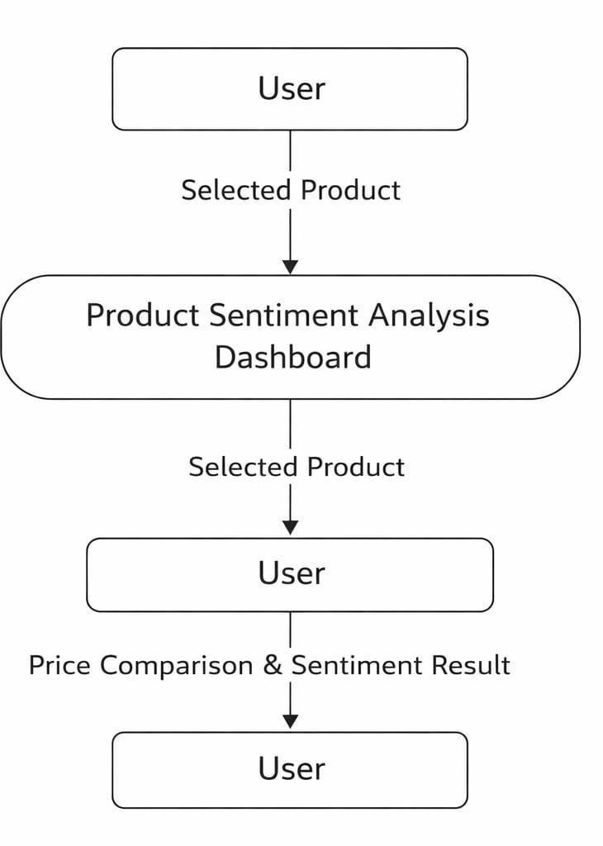

Figure 5.1.1 :LEVEL 0 DFD

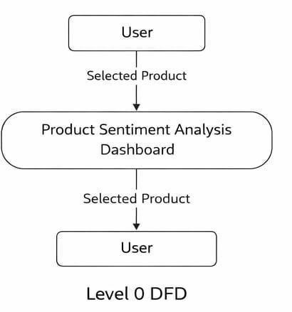
Figure 5.1.2 :LEVEL 0 DFD

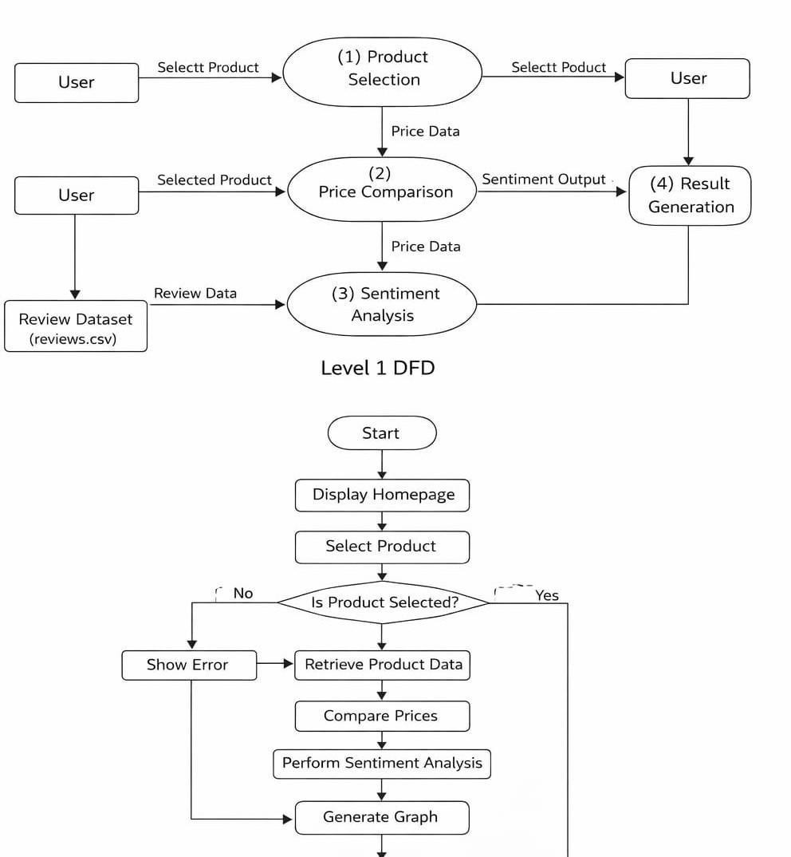
stop

Figure 5.1.3 :LEVEL 1 DFD

  - SYSTEM FLOW DIAGRAM
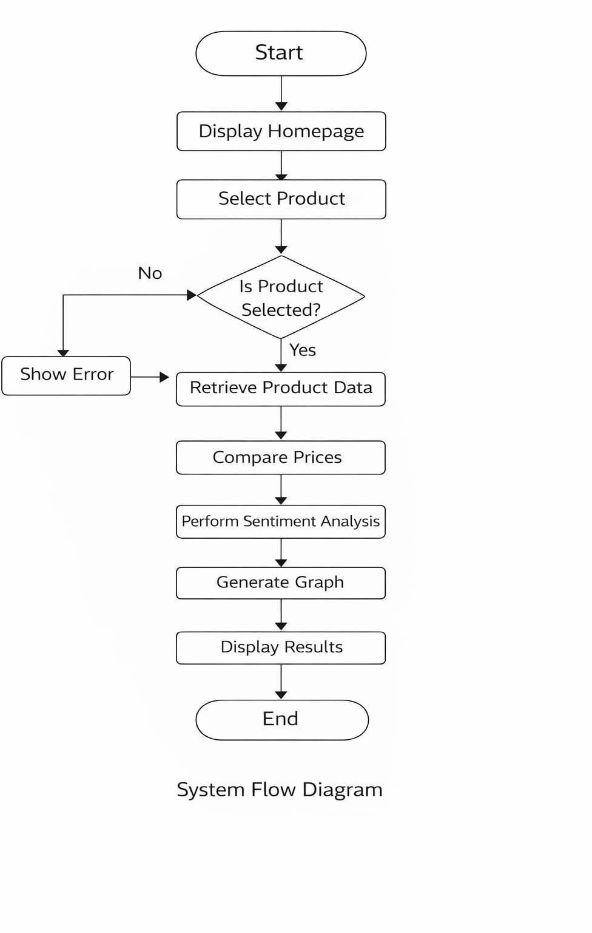

SYSTEM TESTING AND IMPLEMENTATION

System Testing and Implementation is an essential phase in software development. It ensures that the developed system works correctly according to the specified requirements. Testing helps identify errors, validate functionality, and confirm that all modules perform as expected.
In the Product Sentiment Analysis Dashboard, testing was conducted to verify the accuracy of price comparison, sentiment classification, and result generation. The implementation phase ensures that the system is properly deployed and made ready for use.

SYSTEM TESTING

System testing is performed to ensure that the complete application functions correctly in a real-time environment. The testing process verifies the interaction between different modules such as product selection, price comparison, sentiment analysis, and result display.
The following types of testing were performed:

UNIT TESTING

Unit testing is performed to test individual components of the system independently.
In this project, the following units were tested:

      - Product selection module

      - Price comparison module

      - Sentiment analysis module

      - Graph generation module

Each module was tested separately to ensure correct output for valid inputs.

INTEGRATION TESTING

Integration testing ensures that different modules of the system work together properly.
In this system:

      - Product selection was integrated with price comparison.

      - Price comparison was integrated with sentiment analysis.

      - Sentiment analysis was integrated with result display.

The testing confirmed that data flows correctly between modules without errors.

VALIDATION TESTING

Validation testing ensures that the system meets user requirements. The system was tested to confirm:
      - Correct price comparison between Amazon and Flipkart

      - Accurate sentiment categorization

      - Proper display of results

      - Error handling for invalid inputs

The system successfully met all functional requirements.

BLACK BOX TESTING

Black box testing focuses on testing system functionality without examining internal code.
The following scenarios were tested:

      - Selecting different products

      - Checking correct price output

      - Verifying sentiment distribution

      - Ensuring proper graph display

All outputs were verified against expected results.

WHITE BOX TESTING

White box testing involves examining internal code logic and control flow. In this project:
      - Conditional statements were checked

      - Data processing logic was verified

      - Error handling mechanisms were tested

This ensured proper internal functioning of the application.

SYSTEM IMPLEMENTATION

System implementation refers to deploying the system in a working environment and making it available for users.
The Product Sentiment Analysis Dashboard was implemented as a web-based application using Python and Flask framework. The frontend interface was developed using HTML and CSS, while backend processing was handled using Python libraries.
Implementation Steps:

- Dataset preparation and cleaning

- Backend logic development

- Integration of sentiment analysis module

- Frontend interface design

- Testing and debugging

- Final deployment on local server

The system was successfully executed in a local development environment and tested for real-time performance.

    - TEST CASE TABLE

Test Case ID | Test Description | Input | Expected Output | Actual Output | Result
TC01 | Verify product selection | Select valid product from dropdown | Product selected successfully | Product selected successfully | Pass
TC02 | Validate empty product selection | Click "Compare" without selecting product | Error message displayed | Error message displayed | Pass
TC03 | Verify Amazon price retrieval | Select product | Correct Amazon price displayed | Correct Amazon price displayed | Pass
TC04 | Verify Flipkart price retrieval | Select product | Correct Flipkart price displayed | Correct Flipkart price displayed | Pass
TC05 | Verify price comparison logic | Product with different prices | Lower price platform highlighted | Lower price platform highlighted | Pass
TC06 | Validate sentiment classification | Product review dataset | Reviews categorized into Positive, Negative, Neutral | Reviews categorized correctly | Pass
TC07 | Verify sentiment count accuracy | Select product | Correct count of sentiments displayed | Correct count displayed | Pass
TC08 | Verify graph generation | Sentiment data available | Bar graph displayed properly | Bar graph displayed properly | Pass
TC09 | Verify navigation functionality | Click "Go to Homepage" | Redirect to homepage | Redirected successfully | Pass
TC10 | Verify system performance | Multiple product selections | System responds without delay | System responded quickly | Pass

CONCLUSION

The Product Sentiment Analysis Dashboard was successfully designed and implemented to analyze customer reviews and compare product prices across different platforms. The system integrates price comparison and sentiment classification into a single interactive dashboard, providing meaningful insights to users.
The project demonstrates how data analysis techniques can be applied to real- world problems such as understanding customer satisfaction and helping users make informed purchasing decisions. By categorizing reviews into positive, negative, and neutral sentiments, the system provides a clear understanding of overall product perception.
The graphical representation of sentiment distribution improves result interpretation, making it easier for users to analyze trends quickly. Additionally, the price comparison feature enhances practical usability by identifying the more affordable platform for a selected product.
The system was tested using multiple test cases to ensure accuracy, reliability, and performance. All modules functioned as expected, confirming that the system meets the defined objectives.
Overall, the project successfully achieves its goal of combining sentiment analysis and price comparison into a user-friendly web application. It demonstrates practical knowledge in data processing, web development, and system design.

Scope for Future Enhancement

The current Product Sentiment Analysis Dashboard focuses on analyzing and visualizing customer sentiments based on available product review data. In the future, the system can be enhanced with more advanced features to improve its accuracy, usability, and analytical capabilities.
One possible enhancement is the integration of real-time data collection from e-commerce platforms and social media sources. This would allow the system to continuously analyze new reviews and provide up-to-date sentiment insights.
The system can also be improved by implementing advanced machine learning and deep learning models to achieve more accurate sentiment classification and to detect complex emotions such as sarcasm or mixed opinions.
Another enhancement would be adding multilingual sentiment analysis, enabling the system to analyze reviews written in different languages. This would make the dashboard more useful for global products and markets.
Additionally, future versions of the dashboard could include predictive analytics, helping businesses forecast product trends and customer satisfaction levels based on sentiment patterns. Mobile compatibility and more interactive visualization tools could also be added to improve the user experience.
With these improvements, the Product Sentiment Analysis Dashboard can evolve into a more powerful decision-support system for businesses and product manager

BIBLIOGRAPHY

The following resources were referred to during the development of this project:
- Python Official Documentation – https://www.python.org
- Flask Framework Documentation – https://flask.palletsprojects.com

- Pandas Library Documentation – https://pandas.pydata.org

- Matplotlib Documentation – https://matplotlib.org

- Scikit-learn Documentation – https://scikit-learn.org

- Online tutorials and technical blogs related to sentiment analysis and data visualization

APPENDICES

    - SOURCE CODE

The complete source code of the Product Sentiment Analysis Dashboard is attached in the appendix section. It includes:
- Backend Python files

- Sentiment analysis logic

- Flask application file

- HTML frontend templates

- Dataset file (reviews.csv)

APPENDIX – SOURCE CODE

Appendix A –
Main Application File (app.py)
from flask import Flask, render_template, request import pandas as pd import matplotlib.pyplot as plt import os
app = Flask( name ) #

# Load Dataset

#

data = pd.read_csv("reviews.csv") # # Sentiment Analysis Function #
def generate_sentiment(review): review = review.lower()

positive_words = ["good", "excellent", "amazing", "best", "nice", "love"] negative_words = ["bad", "worst", "poor", "terrible", "hate"]
for word in positive_words: if word in review:

return "Positive" for word in negative_words: if word in review:
return "Negative" return "Neutral"

# Apply sentiment classification data["Sentiment"] = data["review"].apply(generate_sentiment)

#

# Homepage Route # @app.route('/') def home():
products = data["product_name"].unique()

return render_template("index.html", products=products) #
# Compare Route #

@app.route('/compare', methods=["POST"]) def compare(): selected_product = request.form.get("product") if not selected_product:
return "Please select a product" # Filter data for selected product product_data = data[data["product_name"] == selected_product] # Separate by platform

amazon_data = product_data[product_data["platform"] == "Amazon"] flipkart_data = product_data[product_data["platform"] == "Flipkart"] # Example static price logic (replace with real data if needed) amazon_price = 5000 + len(amazon_data)
flipkart_price = 4800 + len(flipkart_data) if amazon_price < flipkart_price: cheaper_platform = "Amazon" else:
cheaper_platform = "Flipkart" # Sentiment Count

positive_count = len(product_data[product_data["Sentiment"] == "Positive"])

negative_count = len(product_data[product_data["Sentiment"] == "Negative"])
neutral_count = len(product_data[product_data["Sentiment"] == "Neutral"]) #

Generate Bar Graph

sentiments = ["Positive", "Negative", "Neutral"]

counts = [positive_count, negative_count, neutral_count] plt.figure() plt.bar(sentiments, counts)

plt.title("Sentiment Analysis Result") plt.xlabel("Sentiment") plt.ylabel("Count")
graph_path = "static/sentiment_graph.png" plt.savefig(graph_path) plt.close()
# Business Insight0

if positive_count > negative_count:

insight = "Overall customer feedback is positive." elif negative_count > positive_count:
insight = "Product needs improvement based on reviews." else: insight = "Customer feedback is mixed." return render_template(
"compare.html", product=selected_product, amazon_price=amazon_price, flipkart_price=flipkart_price,

cheaper_platform=cheaper_platform, positive=positive_count, negative=negative_count, neutral=neutral_count, insight=insight, graph=graph_path
)

if name == " main ": app.run(debug=True)

APPENDIX B

index.html

<!DOCTYPE html>

<html>

<head>

<title>Product Sentiment Analysis Dashboard</title>

</head>

<body>

<h1>Product Sentiment Analysis Dashboard</h1>

<form action="/compare" method="POST">

<label>Select Product:</label>

<select name="product">

{% for product in products %}

<option value="{{ product }}">{{ product }}</option>

{% endfor %}

</select>

<button type="submit">Compare</button>

</form>

</body>

</html>

APPENDIX C

compare.html

<!DOCTYPE html>

<html>

<head>

<title>Comparison Result</title>

</head>

<body>

<h2>Price Comparison for {{ product }}</h2>

<p>Amazon Price: ₹{{ amazon_price }}</p>

<p>Flipkart Price: ₹{{ flipkart_price }}</p>

<p><strong>Cheaper Platform: {{ cheaper_platform }}</strong></p>

<h2>Sentiment Analysis Result</h2>

<p>Positive Reviews: {{ positive }}</p>

<p>Negative Reviews: {{ negative }}</p>

<p>Neutral Reviews: {{ neutral }}</p>

<img src="/{{ graph }}" alt="Sentiment Graph">

<h3>Business Insight</h3>

<p>{{ insight }}</p>

<br>

<a href="/">Go to Homepage</a>

</body>

</html>

APPENDIX D

Sample Dataset Structure (reviews.csv)

category,product_name,platform,review

Electronics,Product A,Amazon,This product is very good and amazing Electronics,Product A,Flipkart,Good quality but price is high Electronics,Product B,Amazon,Worst experience ever Electronics,Product B,Flipkart,Excellent performance and best product

APPENDIX – SAMPLE INPUT AND OUTPUT SCREENS

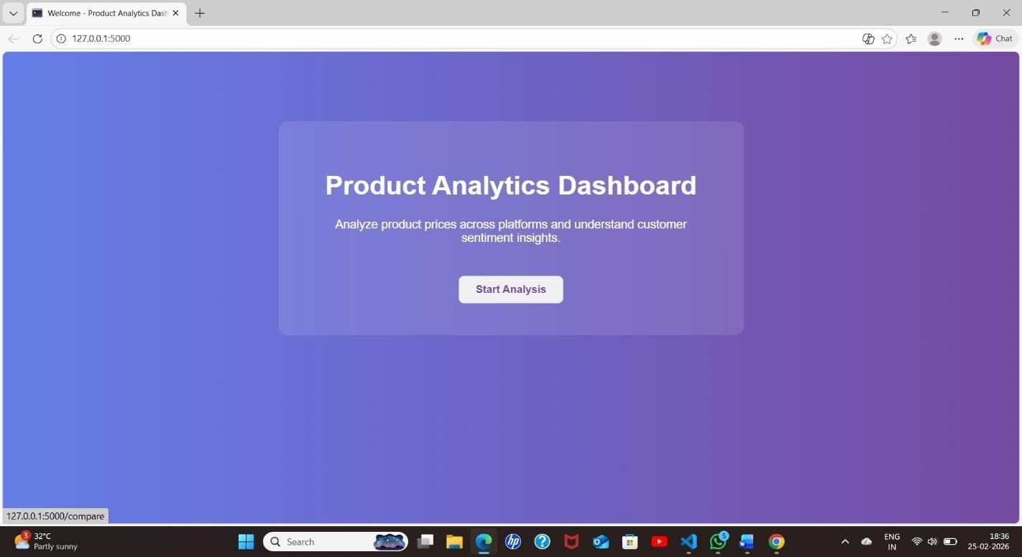

Figure A1: Homepage of Product Sentiment Analysis Dashboard

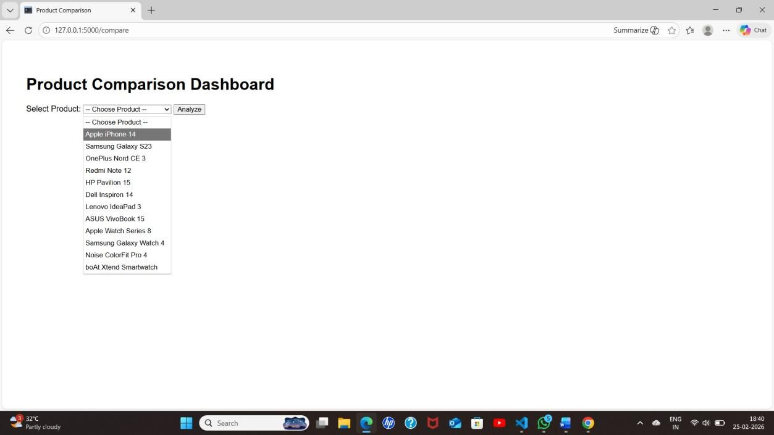

Figure A2: Product Selection Interface

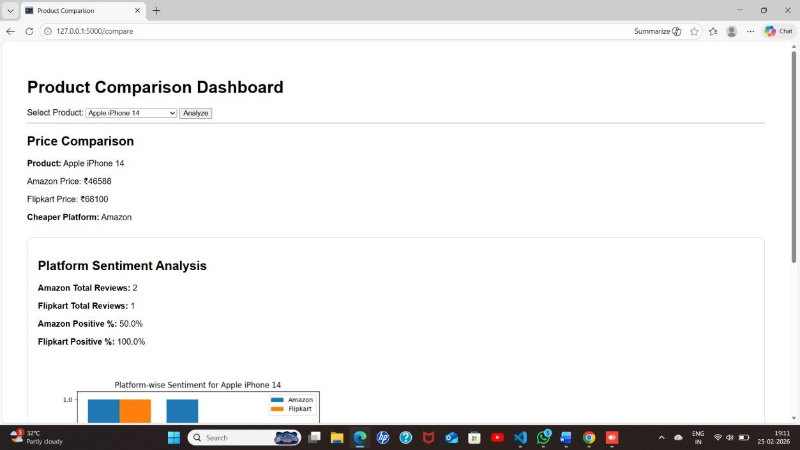

Figure A3: Price Comparison Output

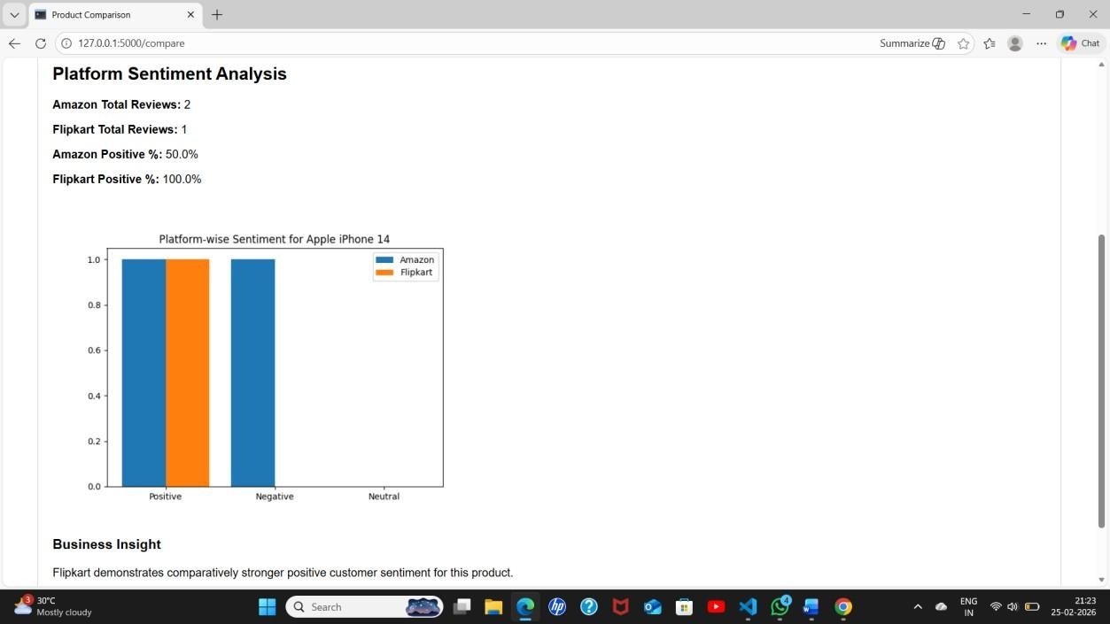
Figure A4: Sentiment Classification Result

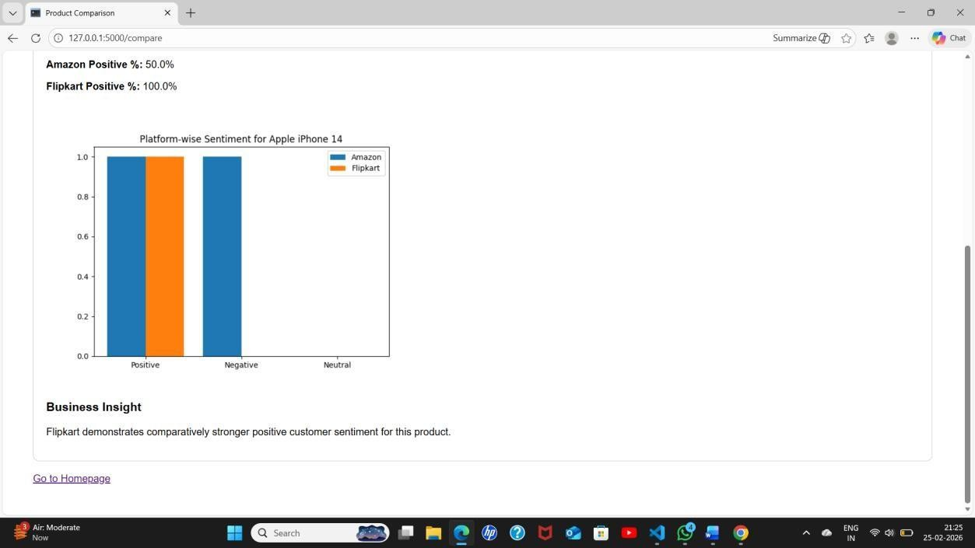

Figure A5: Graphical Representation of Sentiment Analysis

